Unveiling Canine Personalities: Deep Learning-Based Dog Character Identification



Abstract—The current paper aims to explore the use of artificial intelligence-based images processing methods to identify personality traits in dogs by using their photographs. This is a fine-grained image recognition task, also known as sub-category recognition, wherein the objective is to perform a more detailed sub-classification of images belonging to the same category, specifically determining the breed or personality of dogs depicted in the given images. By leveraging the efficiency of artificial intelligence techniques in image applications, this research proposes a comprehensive approach that uses multiple deep learning models as classifiers and object detectors to learn and recognize visual features relevant to dog personalities. Experimental results demonstrate significant accuracy in the deep learning models' classification of dog personalities.

Keywords: fine-grained image recognition, Dog Personality, Artificial Intelligence

Introduction
The environment of animal shelters often faces limitations in space, resulting in an overwhelming number of animals being housed. These conditions place significant physical and psychological stress on the shelter animals, leading to physiological and behavioral problems [1]. The stress in shelter environments profoundly affects the animals, and if their physical and psychological needs are not met, they may exhibit abnormal behavior and negative physiological reactions, such as increased heart rate or decreased metabolism and immune function, which can ultimately affect adoption rates [2] and the establishment of harmonious relationships between adopters and pets, increasing the likelihood of returns.

The initial establishment of a low-demand matching system for human-canine compatibility is proposed. Inspired by Thompson Darcy concept of "On Growth and Form," which states that an organism's form reflects the forces it endures, canine temperament is primarily determined by genetics and the growth environment [3]. Breeding of dogs is intentionally selective, aiming for specific traits or functionalities. In simple terms, canine behavior, habits, temperament, and innate functions should be closely related and interconnected. Physiognomy can be considered a scientific concept. If canine temperament can be predicted based on the physical characteristics of dogs, providing references for potential adopters, the adoption rates can be improved. This study aims to provide research results as a reference for shelter management, enhancing animal welfare, increasing adoption rates, alleviating the crisis, and entering a positive cycle.

Improving the success rate of working dog development is a significant issue [4]. Breeding programs and training require careful selection of dogs, and the results of temperament tests, which assess dogs' behavioral responses, should provide valuable information for selection. Ideally, the characteristics should be hereditary, enabling rapid progress in breeding programs. However, current methods involving breed, pedigree, and various temperament tests still do not achieve satisfactory selection success rates. Therefore, if canine temperament can be predicted based on external morphology, establishing physiognomy for dogs and proposing an effective selection system would benefit both animal welfare (by identifying shelter dogs with training potential, resulting in improved behavior post-training and increased adoption rates) and canine-related industries (training of working dogs and service dogs is costly, and higher training success rates would reduce costs and benefit more individuals in need).

Understanding a dog's temperament is crucial for fostering better human-canine relationships. Traditional methods relying on human observation are time-consuming and subjective. The emergence of artificial intelligence and deep learning has opened up new possibilities for using photos to identify a dog's temperament. However, obtaining sufficient training data poses a challenge, requiring large datasets with annotated images of diverse breeds and personality traits.

Convolutional Neural Networks (CNNs) are powerful models in deep learning, widely used in image recognition, detection, and classification tasks [5]. Compared to traditional methods like SIFT and HoG [6], CNNs have shown superior performance and have achieved impressive results in fine-grained image recognition. The core concept of CNN involves extracting features through multiple convolution and pooling layers, followed by classification using fully connected layers. This architecture is well-suited for recognizing canine temperament from dog images, enabling automatic feature learning and facilitating personality analysis and identification

Notable studies, such as Borwarnginn et al. and Thongkanchorn et al., utilized CNN and transfer learning to surpass traditional dog breed classification methods [7]. Similarly, Tsai et al. and Lin et al. proposed multi-feature-dependent detection for emotion inference using deep learning techniques [8]. Moreover, Rekaesh et al. and Kumar et al. employed deep learning for breed identification, achieving accurate recognition using methods based on grid division and convolutional neural networks [9]. These studies demonstrate the potential of deep learning in advancing dog temperament recognition.

However, due to the difficulty and lack of related research in fine-grained image recognition, this study aims to establish a deep learning approach for recognizing dog personality, delving deeper into the problem of fine-grained image recognition in dog personality recognition. The significance of this research lies in analyzing the performance of deep learning models in recognizing dog personality traits and comprehensively understanding this type of recognition problem. The contributions primarily include:

1. Establishing the dataset required for the dog personality object detection model.
2. Designing an effective object detection and classification workflow.
3. Experimenting and analyzing the differences between the dog personality object detection model and the dog personality classification model.

Through these contributions, this research provides an effective method to understand dog personality, addresses the problem of fine-grained image recognition, and further improves and develops dog personality recognition techniques. It offers valuable references and guidance to advance the field. The rest of this paper is organized as follows: The first section provides an overview of the topics, including Convolutional Neural Networks (CNNs), Dog Breed Identification, Fine-grained Image Recognition, and Image Classification using a self-collected dataset for deep learning. The second section presents a summary of the relevant research work and introduces the models referenced in this paper. Moving on to the third section, it outlines the process of data collection, as well as the methods employed for training, testing, and validating the dataset. The fourth section delves into the analysis of the data, categories, models, performance evaluation, and feature recognition. Lastly, the fifth section discusses the differences observed among various training models.

RELATED WORKS
In modern society, dogs are regarded as loyal companions and family members, and there is significant interest and concern about their personalities and behaviors. Many studies have indicated that specific genes can influence the fur color of organisms, which in turn can affect their morphological appearance and behavioral traits [10]. Similar to humans, there is a correlation between facial appearance and physique in dogs. Research has found that leaner dogs tend to be more timid, while taller and heavier dogs tend to be more lethargic, less curious, and less energetic. However, the evidence for these relationships is still insufficient, and it is suggested that exploring this relationship in more nuanced measures of physique within a single breed could be worthwhile [11].

There is a correlation between a dog's personality and the genetic polymorphisms of its breed [12]. Therefore, when selecting breeds or individual dogs for breeding, whether for working or as pets, both physical health, behavior, and morphological appearance are important considerations [13]. Boldness is a crucial aspect of a dog's personality, and breed is one of the determining factors. This study found that behavioral tendencies may be influenced by historical purposes, regardless of whether those purposes still factor into selective breeding [14]. Breed and gender differences are evident in activity level, snapping, excessive barking, demand for affection, aggression toward other dogs, aggression towards family members, territorial defense, watchdog barking, trainability, and ease of housetraining [15].

The probability of shelter dogs being returned can be predicted based on their age and breed [16]. Adult dogs have a higher likelihood of being returned. Breeds like pit bulls are frequently returned and often face euthanasia. Herding breeds are more commonly returned compared to toy and terrier breeds. The main reasons for returns are behavior problems and the inability to coexist with existing pets in the adoptive home. Therefore, resources should be invested in behavior training for adopted dogs, educating adopters, and providing post-adoption support systems.

The robustness of deep learning models is evident in the works of Sermanet et al. and Simon et al., who utilized CNNs with various architectures to achieve significant results in image recognition, highlighting the capability of CNN models in effectively handling image feature recognition [17]. Additionally, Liu et al. introduced an attentional region localization approach that enhances recognition performance by focusing on important regions in images, further emphasizing the robustness of deep learning models [18]. Furthermore, Raymond et al. successfully trained an identification system using the NASNetMobile architecture [19], and Jiang et al. implemented large-scale object detection using YOLOv7 in [20]. These studies showcase the applications and achievements of different deep-learning models in image recognition].

By utilizing deep learning techniques, a pet monitoring system can be developed to identify a dog's emotional state based on the characteristics of its muzzle, tail, and barking. This system can enhance traditional single-image recognition accuracy by employing faster R-CNN models [8]. This series of studies employ machine learning techniques to automatically identify and determine a dog's emotional state (anger, happiness, fear, relaxation) based on the dog's body posture. Next, the DeepLabCut framework is used to establish 24 key body features of the dog, quantifying them as 24 coordinate values to classify the dog's emotional state. The success rate is around 60-70%, surpassing the judgment level of an average person [21].

Moreover, Huanyu Jiang et al. presented a review on the application of Convolutional Neural Networks (CNNs) for plant leaf disease classification. They summarized the major challenges in plant disease classification using CNNs and provided corresponding solutions. The classification models based on CNN architecture extract features through convolutional layers, max-pooling layers, and fully connected layers. The end of the architecture consists of a classifier that classifies the high-level semantic features extracted by the feature extractor. The main challenge in using CNN-based deep learning for plant disease classification is the limited size and diversity of the dataset [22].

Additionally, Alzbeta Tureckova et al. conducted a study on dog face detection using the YOLO network. Object detection with the YOLO network is expected to be fast, accurate, and capable of recognizing various objects. They utilized a large dataset of dog faces collected from two different sources and documented the training process of the detector. However, creating a large-scale object detection dataset is time-consuming and expensive, as it requires more than simple classification labels, resulting in fewer available datasets for object detection compared to classification datasets[23].

There are five deep learning models, which have achieved significant achievements in computer vision tasks and possess different strengths and applicability. This includes four classification models, namely NASNetMobile [24], ResNet50 [25], Inception V3 [26], and EfficientnetV2M [27], and one object detection model, Yolov7 [28]. A brief introduction to the five aforementioned models is summarized in Table 1.

Table 1. Overview of Five Models
Model | Introduce | Advantage
NASNetMobile | An automatically searched neural network architecture. | Better image classification and feature extraction capabilities.
Resnet 50 | A convolutional neural network (CNN) model with deep residual connections. | Excellent performance in visual tasks such as image classification, object detection, and image segmentation, with good transfer learning ability.
Inception V3 | A CNN model that improves feature extraction by simultaneously learning multiple features at different scales. | Shallow network structure, resulting in shorter training and inference times.
EfficientnetV2M | An improved version of the EfficientNet series of models, combining AutoML techniques for network architecture search to find efficient and compact network structures. | Performs well in scenarios with limited computational resources, demonstrating good image classification and object detection performance
YOLOv7 | A state-of-the-art object detection model that uses a single convolutional network to simultaneously predict bounding boxes and class probabilities | Fast and accurate object detection, suitable for real-time applications, with efficient utilization of computational resources.

As for Yolov7, it is an object detection algorithm that combines the model preprocessing method of Yolov5. It utilizes Mosaic data augmentation, which is suitable for detecting small objects. In terms of architecture, Yolov7 introduces an extended version of the Efficient Layer Attention Network (ELAN) called E-ELAN. It incorporates techniques like Expand, Shuffle, and Merge Cardinality to enhance the learning capacity of the network without disrupting the original gradient pathways. Group convolution is used to expand the channels and cardinality of the computation blocks within the architecture. This allows different groups of computation blocks to learn distinct features.

By organizing these research works, a better understanding of traditional methods, different CNN architectures, and attention mechanisms in dog feature recognition can be obtained. These studies offer valuable insights and lay the groundwork for the current research. Hence, the aim of this study is to leverage the achievements of these prior research works of using deep learning techniques to propose a method focused on dog feature recognition. The objective of this research is to achieve higher accuracy and performance in dog image recognition using this method, providing practical solutions for research and applications in related fields.

PROPOSED METHOD
Based on the breed-specific temperament classification results published by Drs. Ben and Lynette Hart in the Journal of the American Veterinary Medical Association in 1985, in conjunction with the publicly available breed-specific dog image database provided by Stanford University, we have labeled the 43 breeds of dogs with seven personality traits (as shown in the diagram below). This serves as the research foundation for AI-based dog physiognomy studies, and the labeling process has been completed.

Dataset Descriptions
The dataset used in this paper is a subset of the publicly available breed dog image database provided by Stanford University, consisting of approximately 8000 images. Two different recognition approaches are employed: direct classification of dog personalities into 7 categories, and first determining the breeds of the dogs among 43 classes, followed by mapping them to the 7 personality categories based on a reference table. The dataset is divided into training, testing, and validation sets, with the training set accounting for 90% of the total, the testing set for 8%, and the validation set for 2%. Additionally, the 7 major dog personalities in this dataset are determined based on the breeds of the 43 dog species as shown in Table 2.
Table 2. Behavioral profiles of Dog Breeds
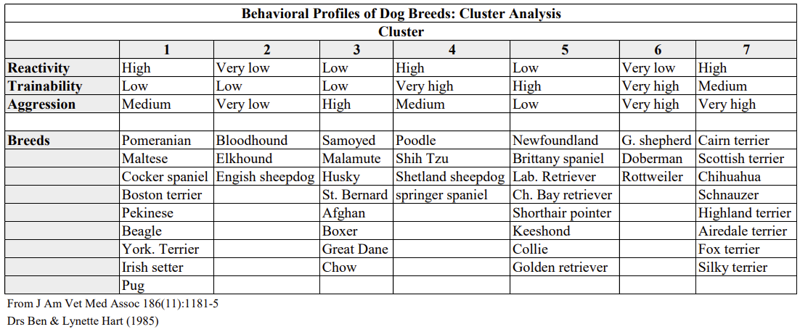

Model Design

In this study, five models were used for training and prediction. The models employed were NASNetMobile, ResNet50, Inception V3, EfficientnetV2M, and Yolov7. After obtaining the necessary formatted and resized data, further fine-tuning of convolutional neural networks (CNN) is performed, utilizing application techniques, CNN architectures, methods, hyperparameters, and pre-trained models as frozen weights. Due to the subtle differences among these breeds, CNN must consider small discriminative features to eliminate ambiguities for well-trained categories, meeting the requirements of fine-grained image recognition, such as distinguishing between Husky and Malamute breeds. The performance of these models was compared and evaluated in the context of the study. The flowchart of the proposed methods is illustrated in Figure 1.

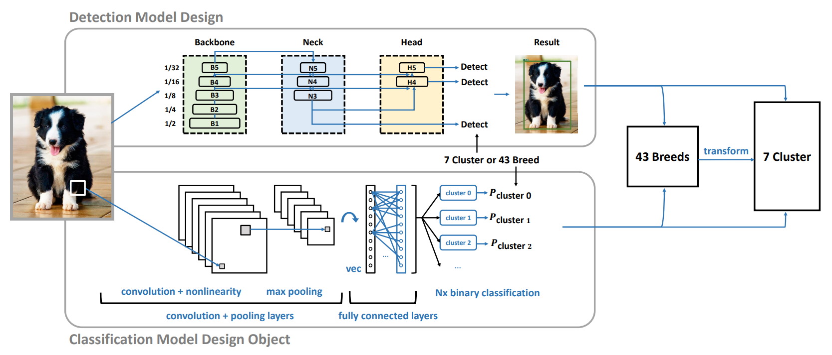

Figure 1. Object Detection and Classification Model Design Architecture

This study incorporates two types of architecture: object detection and classification. Firstly, the object detection model is based on a three-level architecture consisting of Backbone, Neck, and Head. The Backbone is responsible for feature extraction and captures features at different scales through a pyramid structure. The Neck further expands and fuses the features, improving accuracy through upsampling and lateral connections. The Head performs the detection task by generating a green pyramid structure through downsampling and utilizes an anchor-based method for multi-scale detection. This three-level architecture effectively combines feature extraction, fusion, and multi-scale detection techniques, enabling accurate and fast object detection suitable for real-time applications. Secondly, the classification model is a deep learning model used for image recognition and computer vision. It extracts features through convolutional layers, downsamples into important features through pooling layers, and performs classification using fully connected layers. The convolutional layers capture local features of the image, while the pooling layers reduce the size of the feature maps and enhance translation invariance. By combining convolutional, pooling, and fully connected layers, the model automatically learns image features and achieves accurate image classification and detection tasks, bringing significant advancements to computer vision.

Evaluation Methods

After establishing the model architecture, different hyperparameters are set for training and evaluation. By setting various parameter combinations and using grid search method to iterate through them, the optimal parameter combination is found. During the training of the neural network, training data is fed into the first layer of the network, and each neuron updates its weights through backpropagation based on whether the output matches the label. This process is repeated until the model learns new features from the existing data. However, it is unknown whether the trained model has indeed learned the new features.

The performance of the model is evaluated using metrics such as accuracy, precision, recall, and F1 score. Before introducing these metrics, the concept of a confusion matrix must be introduced. The confusion matrix displays the correct or incorrect predictions in binary classification. It consists of four elements: true positive (TP, correctly predicted positive value), false positive (FP, falsely predicted positive value), true negative (TN, correctly predicted negative value), and false negative (FN, falsely predicted negative value). Accuracy can be calculated as follows:

- Accuracy: Represents the proportion of correct predictions made by the model among all samples.

$$Accuracy=\frac{TP+TN}{TP+FP+TN+FN}$$

- Precision: Represents the proportion of true positive samples among the samples predicted as positive.
$$Precision=\frac{TP}{TP+FP}$$

- Recall: Represents the proportion of true positive samples among all positive samples in the entire dataset.
$$Recall=\frac{TP}{TP+FN}$$

- F1 score: It is the weighted average of precision and recall.

$$F1=(\frac{2}{{Recall}^{-1}+{Precision}^{-1}})=2×\frac{Precision×Recall}{Precision+Recall}$$

When evaluating the performance of Yolov7, the following two metrics are additionally used:

- AP(average precision): It is the average of the highest precision at different recall levels.

$$AP=\frac{1}{11}\sum_{0,0.1...1.0}{P_{smooth(i)}}$$
- mAP(mean average precision): It is the average precision and average AP value across each class.
$$mAP=\frac{\sum_{j=1}^{S}{AP(j)}}{S}$$

To further evaluate the models' performance, the Receiver Operating Characteristic (ROC) curve is employed. The ROC curve illustrates the trade-off between the True Positive Rate (TPR) and the False Positive Rate (FPR) at different decision thresholds. A curve that closely approaches the top-left corner indicates superior performance, while a curve closer to the diagonal line suggests performance similar to random chance. The Area Under the Curve (AUC) is a metric used to quantify the overall performance of the model. A higher AUC value indicates better discrimination ability, with a value of 1 indicating perfect classification. By examining the ROC curves and calculating the AUC, we can gain insights into the models' ability to distinguish between positive and negative instances and make informed comparisons. This analysis of the ROC curves and AUC values provides valuable information on the performance and efficacy of each model, aiding in the selection of the most suitable model for the given classification task.

RESULT AND DISCUSSION
This section reports performance results with a detailed analysis. In addition to presenting numerical values,
graphical visualizations are provided to offer further insights into examining the effectiveness of the proposed method. Furthermore, key propositions derived from observations will be discussed thoroughly. Table 3 presents the performance statistics of each model.

Table 3. Performance Statistics
Model | Method | Accuracy | Precision | Recall | F1 score
NASNetMobile | 43 Breed | 0.93 | 0.93 | 0.93 | 0.93
 | 7 Cluster | 0.91 | 0.92 | 0.91 | 0.91
Resnet50 | 43 Breed | 0.95 | 0.95 | 0.95 | 0.95
 | 7 Cluster | 0.91 | 0.91 | 0.91 | 0.91
InceptionV3 | 43 Breed | 0.95 | 0.95 | 0.95 | 0.95
 | 7 Cluster | 0.98 | 0.98 | 0.98 | 0.98
EfficientnetV2M | 43 Breed | 0.98 | 0.98 | 0.98 | 0.98
 | 7 Cluster | 0.97 | 0.97 | 0.97 | 0.97
Yolov7 | 43 Breed | 0.93 | 0.93 | 0.77 | 0.85
 | 7 Cluster | 0.86 | 0.88 | 0.72 | 0.79

In the 43 breeds classification task, all models achieved high accuracy, precision, recall, and F1 score, with EfficientnetV2M performing the best with an accuracy of 0.98 and consistently high scores across all metrics. Resnet50 and InceptionV3 also demonstrated excellent performance with accuracies of 0.95. For the 7 clusters classification task, InceptionV3 achieved the highest accuracy of 0.98, indicating its strong capability in cluster classification. EfficientnetV2M also performed well with an accuracy of 0.97. However, it is worth noting that Yolov7 had slightly lower performance compared to the other models, especially in terms of recall and F1 score. This suggests that Yolov7 may have some limitations in accurately capturing all breeds or clusters. Overall, the results indicate that the deep learning models used in this study, particularly EfficientnetV2M and InceptionV3, are effective in both breed and cluster classification tasks, showcasing their potential for dog feature recognition and classification.

Further, The ROC curves for the four models (NASNetMobile, EfficientnetV2M, InceptionV3, ResNet50) and the Yolov7 object detection method after training are displayed in Figure 2. The curves depict the relationship between the True Positive Rate (TPR) and False Positive Rate (FPR) at different classification thresholds.

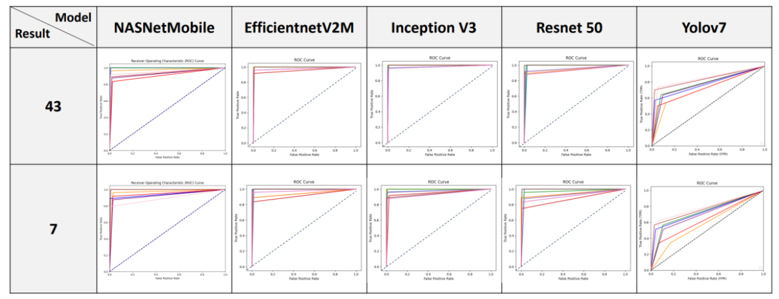
Figure 2. ROC Statistics Results

Based on the ROC curves, all four models show excellent performance, with curves that approach the top-left corner, indicating high TPR and low FPR. This suggests that these models have good discriminatory power and can effectively distinguish between positive and negative instances. The Yolov7 object detection method also demonstrates a reasonable performance, although its ROC curve is slightly below the curves of the classification models. This indicates that the Yolov7 method may have a slightly higher FPR compared to the classification models. Overall, the ROC curves provide a visual representation of the model’s performance, allowing for a comparative analysis of their ability to correctly classify positive and negative instances. These curves serve as valuable tools for evaluating and selecting the most appropriate model for a given classification task.

From Table 3 and Figure 2 above, it can be observed that except for the Inception V3 model, the performance results of the other models indicate that the approach of training on 43 breeds first and then mapping them to the 7 personality categories yields better performance compared to directly training on the 7 personality categories. This suggests that when dealing with multi-class classification problems, using the approach of training on breeds first and then predicting personality may lead to improved results in deep learning models.

In order to visually represent patterns, correlations, and variations in the data, Figure 3 presents heatmaps for each model and the Yolov7 object detection technique. Heatmaps provide an intuitive and visual way to understand the data. Each value in the data is associated with a color, allowing for a straightforward comparison of values. The intensity of the color represents the magnitude of the value, and a gradient color map is used (ranging from dark blue to bright red), where red indicates higher values or intensity. By comparing the color intensities between different regions or rows/columns, the differences between the data can be intuitively compared. The image (denoted as "img") represents the original image. The numbers 1 to 4 correspond to the NASNetMobile, Resnet50, InceptionV3, and EfficientnetV2M models, respectively. The number 5 represents the Yolov7 object detection technique.

From this analysis, it can be observed that the highlighted regions (red portions) in the heatmaps of NASNetMobile and Yolov7 align relatively well with the actual location of the dogs. Among them, Yolov7 shows a more focused and accurate identification of the regions of interest. However, when multiple dogs are present, Yolov7 can only focus on one of them. Among the Resnet50, InceptionV3, and EfficientnetV2M models, the results generated by InceptionV3 appear to be the most accurate. The subpar performance of the remaining models may be attributed to insufficient training iterations and the freezing of certain convolutional layers. InceptionV3, compared to the other two models, employs shallower convolutional layers. Future research directions could involve using different data augmentation techniques and adjusting the depth of frozen and fine-tuned layers.

img | 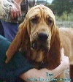 | 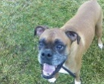 | 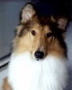 | 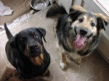 | 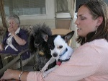
1 | 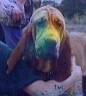 | 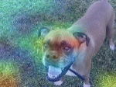 | 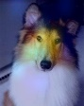 | 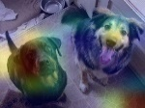 | 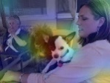
2 | 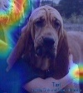 | 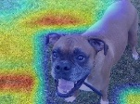 | 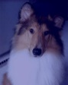 | 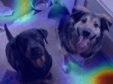 | 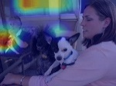
3 | 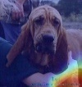 | 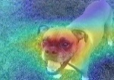 | 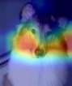 | 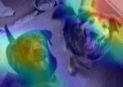 | 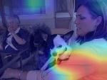
4 | 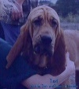 | 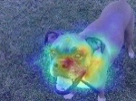 | 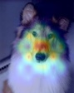 | 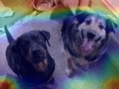 | 
5 | 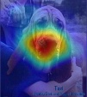 | 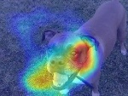 | 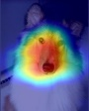 | 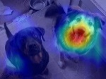 | 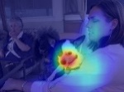
Figure 3. Heatmap Visualization of Deep Learning Model Using GradCam

The environment in animal shelters significantly impacts animal welfare and adoption rates. Predicting the temperament traits of dogs based on their morphology can help improve adoption and working dog training rates. This research on campus stray dogs, as presented in Table 3, contributes to analyzing the characteristics and distribution of such dogs. The letters A to D correspond to the NASNetMobile, Resnet50, InceptionV3, and EfficientnetV2M models, respectively, while the letter E represents the Yolov7 object detection technique.

Table 4. Identification results for campus stray dogs.
image |  | 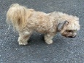 | 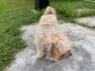 |  | 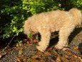
A | 3 | 3 | 1 | 0 | 3
B | 0 | 3 | 3 | 3 | 3
C | 3 | 3 | 3 | 3 | 3
D | 3 | 3 | 3 | 3 | 3
E | 6 | 0 | 6 | 3 | 2
image | 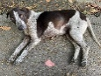 | 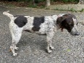 | 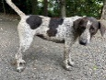 | 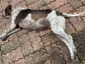 | 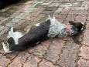
A | 3 | 4 | 4 | 3 | 0
B | 0 | 0 | 4 | 0 | 6
C | 4 | 5 | 5 | 4 | 4
D | 4 | 4 | 4 | 4 | 4
E | 4 | 4 | 4 | 4 | 4
image | 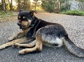 | 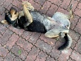 | 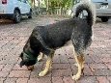 | 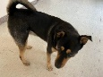 | 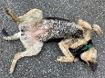
A | 5 | 1 | 1 | 1 | 6
B | 5 | 0 | 5 | 5 | 6
C | 5 | 5 | 5 | 5 | 5
D | 5 | 5 | 5 | 5 | 5
E | 5 | 5 | 2 | 4 | 4

According to Table 4, it can be observed that the recognition results of Method 4 are quite consistent, while the results of other models are inconsistent. This could be attributed to various factors such as model hyperparameter tuning, data preprocessing methods, etc. Additionally, conducting expert surveys would be necessary to evaluate whether these models trained on purebred dogs can accurately recognize the reactivity, trainability, and aggression of mixed-breed dogs, aligning with their inherent characteristics. By gaining a deeper understanding of the differences between models and comprehending the strengths and limitations of each model, appropriate model selection and adjustments can be made for specific application scenarios, thereby enhancing the overall recognition performance.

CONCLUSION
This research has made contributions in the field of image processing by recognizing the personality traits of dogs. It has achieved fine-grained image recognition using artificial intelligence techniques, which involves a more detailed classification of dog images within the same category to determine their breed or personality. Furthermore, a comprehensive approach combining multiple deep learning models as classifiers and object detectors has been proposed to learn and identify visual features related to dog personalities. The experimental results have shown significant achievements in dog personality classification, demonstrating the potential of deep learning models in this domain. Moreover, it has provided an important foundation and new possibilities for understanding dog behavior and characteristics.

However, there is still room for improvement in this study. Further research directions can be summarized as follows:
- Dataset augmentation: Increase the number of dog breed and personality images and data to establish a more comprehensive and representative dataset.
- Fine-tuning and transfer learning: Improve the performance of the models in dog breed and personality recognition tasks through fine-tuning and transfer learning using pre-trained models.
- Model ensemble: Combine predictions from multiple models to enhance overall accuracy and robustness, exploring ensemble techniques such as model averaging or stacking.
- Explore advanced architectures: Research and apply state-of-the-art architectures such as EfficientNet or Transformer-based models to provide better results and feature representation capabilities.
- Individualized prediction: Study individualized recognition and analysis to provide more accurate breed and personality predictions for each dog.

These explorations will contribute to improving the accuracy and practicality of dog breed and personality recognition and have positive impacts in the fields of animal protection, breeding, and research.

Acknowledgment
This research was partially supported by the Nanhua University, Taiwan under grant Y111000343.

REFERENCES
[1] Rowan, A., & Kartal, T. (2018). Dog population & dog sheltering trends in the United States of America. Animals, 8(5), 68.
[2] Lindig, A. M., P. D. McGreevy and A. J. Crean (2020). "Musical Dogs: A Review of the Influence of Auditory Enrichment on Canine Health and Behavior." Animals (Basel) 10(1): 127.
[3] THOMSON, J. (1917). On Growth and Form. Nature 100, 21–22
[4] Arvelius, P., Strandberg, E., & Fikse, W. F. (2014). The Swedish Armed Forces temperament test gives information on genetic differences among dogs. Journal of Veterinary Behavior, 9(6), 281-289.
[5] Krizhevsky, A., Sutskever, I., & Hinton, G. E. (2017). Imagenet classification with deep convolutional neural networks. Communications of the ACM, 60(6), 84-90.
[6] Dalal, N., & Triggs, B. (2005, June). Histograms of oriented gradients for human detection. In 2005 IEEE computer society conference on computer vision and pattern recognition (CVPR'05) (Vol. 1, pp. 886-893). IEEE.
[7]Borwarnginn, P., Thongkanchorn, K., Kanchanapreechakorn, S., & Kusakunniran, W. (2019, October). Breakthrough conventional based approach for dog breed classification using CNN with transfer learning. In 2019 11th International Conference on Information Technology and Electrical Engineering (ICITEE) (pp. 1-5). IEEE.
[8] Tsai, M. F., Lin, P. C., Huang, Z. H., & Lin, C. H. (2020). Multiple feature dependency detection for deep learning technology—smart pet surveillance system implementation. Electronics, 9(9), 1387.
[9] Kumar, R., Sharma, M., Dhawale, K., & Singal, G. (2019, December). Identification of dog breeds using deep learning. In 2019 IEEE 9th International Conference on Advanced Computing (IACC) (pp. 193-198). IEEE.
[10] Clyde e. keeler. (1947). Journal of Heredity (Pages 271–277; Vol. 38, Issue 9).
[11] Lester, D. (1983). Body build and temperament in dogs. Perceptual and Motor Skills.
[12] Saetre, P., Strandberg, E., Sundgren, P. E., Pettersson, U., Jazin, E., & Bergström, T. F. (2006). The genetic contribution to canine personality. Genes, Brain and Behavior, 5(3), 240-248.
[13] King, T., Marston, L. C., & Bennett, P. C. (2012). Breeding dogs for beauty and behaviour: Why scientists need to do more to develop valid and reliable behaviour assessments for dogs kept as companions. Applied Animal Behaviour Science, 137(1-2), 1-12.
[14] Starling, M. J., Branson, N., Thomson, P. C., & McGreevy, P. D. (2013). “Boldness” in the domestic dog differs among breeds and breed groups. Behavioural processes, 97, 53-62.
[15] Hart, B. L., & Hart, L. A. (2016). Breed and gender differences in dog behavior. The Domestic Dog: Its Evolution, Behavior and Interactions with People, 119-132.
[16] Powell, L., Reinhard, C., Satriale, D., Morris, M., Serpell, J., & Watson, B. (2021). Characterizing unsuccessful animal adoptions: Age and breed predict the likelihood of return, reasons for return and post-return outcomes. Scientific Reports, 11(1), 8018.
[17] P. Sermanet, A. Frome and E. Real, "Attention for fine-grained categorization", CoRR, vol. abs/1412.7054, 2014.
[18] X. Liu, X., Xia, T., Wang, J., & Lin, Y. (2016). Fully convolutional attention localization networks: Efficient attention localization for fine-grained recognition. arXiv preprint arXiv:1603.06765, 1(2), 4.
[19] Saragih, R. E., & Emanuel, A. W. (2021, April). Banana Ripeness Classification Based on Deep Learning using Convolutional Neural Network. In 2021 3rd East Indonesia Conference on Computer and Information Technology (EIConCIT) (pp. 85-89). IEEE.
[20] Jiang, K., Xie, T., Yan, R., Wen, X., Li, D., Jiang, H., ... & Wang, J. (2022). An Attention Mechanism-Improved YOLOv7 Object Detection Algorithm for Hemp Duck Count Estimation. Agriculture, 12(10), 1659.
[21] Ferres, K., Schloesser, T., & Gloor, P. A. (2022). Predicting dog emotions based on posture analysis using deeplabcut. Future Internet, 14(4), 97.
[22] Lu, J., Tan, L., & Jiang, H. (2021). Review on convolutional neural network (CNN) applied to plant leaf disease classification. Agriculture, 11(8), 707.
[23] Alzbeta, T., Tomas, H., & Zuzana, O. K. (2020, December 21). Turečková, A., Holík, T., & Komínková Oplatková, Z. (2020). Dog face detection using yolo network. In Mendel. Brno University of Technology.
[24] Zoph, B., Vasudevan, V., Shlens, J., & Le, Q. V. (2018). Learning transferable architectures for scalable image recognition. In Proceedings of the IEEE conference on computer vision and pattern recognition (pp. 8697-8710).
[25] Mukti, I. Z., & Biswas, D. (2019, December). Transfer learning based plant diseases detection using ResNet50. In 2019 4th International conference on electrical information and communication technology (EICT) (pp. 1-6). IEEE.
[26] Tan, M., & Le, Q. (2021, July). Efficientnetv2: Smaller models and faster training. In International conference on machine learning (pp. 10096-10106). PMLR.
[27] Wang, C. Y., Bochkovskiy, A., & Liao, H. Y. M. (2023). YOLOv7: Trainable bag-of-freebies sets new state-of-the-art for real-time object detectors. In Proceedings of the IEEE/CVF Conference on Computer Vision and Pattern Recognition (pp. 7464-7475).
[28] J. Deng, J., Dong, W., Socher, R., Li, L. J., Li, K., & Fei-Fei, L. (2009, June). Imagenet: A large-scale hierarchical image database. In 2009 IEEE conference on computer vision and pattern recognition (pp. 248-255). IEEE.

